Student Skill Development Management System
Capstone Project Report
Submitted by: P Sai Bhargav(192411049)
- Aadarsh(192365002)
C.Achyut Venkat(192311102)
Course Name/Code: Internet Programming-CSA4305

Department of Computer Science And Engneering

Date: September 2026

1. Problem Statement and Problem Formulation
Educational institutions run numerous skill-development and employability initiatives, but progress is typically tracked in scattered spreadsheets maintained separately by mentors, placement cells, and faculty advisors. This makes it difficult to answer basic questions such as: which skills is a given student weak in, how is a student progressing over a semester, and which students are ready for a given job role. The absence of a single structured system leads to duplicated effort, inconsistent scoring, and delayed intervention for students who are falling behind.
The problem addressed by this project is: design and implement a Student Skill Development Management System (SSDMS) that centrally records student profiles, a catalogue of skills, periodic skill assessments, and target-role requirements, and that can automatically compute proficiency levels, skill gaps against a target role, progress trends over time, and cohort leaderboards.

2. Objective and Expected Outcomes

2.1 Objectives
- Maintain a persistent, structured record of students, skills, and time-stamped skill assessments.
- Automatically classify a student's proficiency in each skill into qualitative bands (Beginner / Intermediate / Advanced / Expert).
- Compare a student's current skill scores against the requirements of a target job role and quantify the readiness percentage and remaining gap per skill.
- Visualise how a student's skills change over multiple assessment rounds (progress trend).
- Rank students on a cohort leaderboard, both overall and per individual skill.

2.2 Expected Outcomes
- A working, menu-driven application backed by a relational (SQLite) database.
- Automatically generated gap-analysis and progress reports that a mentor can act on.
- Charts summarising cohort-level skill strengths/weaknesses that support data-driven curriculum decisions.
- A reusable, well-documented codebase that can later be extended into a web application.

3. Requirements, Constraints and Assumptions

3.1 Functional Requirements
- FR1: The system shall allow adding, listing students (name, roll number, department, year).
- FR2: The system shall allow adding, listing skills (name, category).
- FR3: The system shall allow recording a dated skill assessment score (0-100) for a student.
- FR4: The system shall compute and display a student's latest skill profile with proficiency bands.
- FR5: The system shall support defining a target role with minimum required scores per skill, and shall compute skill gap and readiness percentage for any student against that role.
- FR6: The system shall show a chronological progress trend for a given student/skill pair.
- FR7: The system shall produce an overall or per-skill leaderboard of the top-N students.

3.2 Non-Functional Requirements
- Data must persist between runs (no data loss on program exit).
- The application should run on a standard Python 3 installation without paid dependencies.
- Response time for any report on a class-sized dataset (tens to low hundreds of students) should be near-instant.

3.3 Constraints
- Single-machine, single-user console application — no network/multi-user concurrency handling.
- No authentication/authorization layer; the system assumes a trusted administrator/mentor as the sole operator.

3.4 Assumptions
- Skill scores are assigned by a mentor/instructor on a 0-100 scale using an agreed rubric external to this system.
- A student's most recent assessment for a skill represents their current proficiency.

4. Application of Relevant Course Knowledge / Concepts
- Relational database design: normalized schema (students, skills, assessments, target_roles, role_requirements) with primary/foreign keys and referential integrity (ON DELETE CASCADE).
- SQL: DDL for schema creation, parameterised DML (INSERT/SELECT) to prevent SQL injection, JOINs and aggregate functions (AVG, MAX, COUNT, GROUP BY) for reporting.
- Object-oriented programming: separation of concerns between the Database access layer, the domain/business-logic layer (SSDMS class), and the presentation layer (CLI).
- Algorithms: banding/classification logic (score to proficiency level), gap computation, and ranking/sorting for leaderboards.
- Data visualisation: use of Matplotlib to turn tabular query results into bar/line charts for analysis and validation.
- Software engineering practice: modular file structure, automated demo/test script, and reproducible sample-data seeding using a fixed random seed.

5. Design / Proposed Solution / Methodology
The system follows a simple three-layer architecture: (1) a Database layer that owns the SQLite connection and schema; (2) an SSDMS domain layer that implements all business rules (adding records, computing profiles, gap analysis, trends, leaderboards); and (3) a presentation layer, which is either an interactive command-line menu (cli.py) or an automated demo/test driver (demo.py) used to validate behaviour and produce the report evidence in this document.

5.1 Entity-Relationship Summary
- students (1) —— (N) assessments (N) —— (1) skills
- target_roles (1) —— (N) role_requirements (N) —— (1) skills

5.2 Proficiency Banding Rule
- 0–39: Beginner | 40–69: Intermediate | 70–89: Advanced | 90–100: Expert

5.3 Skill-Gap / Role-Readiness Rule
For a student and a target role, each required skill contributes gap = max(0, min_required_score − current_score). A skill is 'met' if current_score ≥ min_required_score. Role readiness (%) = (number of skills met / total required skills) × 100.

6. Algorithm / Pseudocode / Flowchart

6.1 Pseudocode — Skill Gap Analysis
FUNCTION skill_gap_analysis(student, role):
profile <- latest score per skill for student
required <- (skill, min_score) pairs for role
gaps <- []
FOR EACH (skill, min_score) IN required:
current <- profile[skill] OR 0
gap <- MAX(0, min_score - current)
met <- current >= min_score
APPEND (skill, min_score, current, gap, met) TO gaps
readiness <- 100 * COUNT(met = TRUE) / COUNT(required)
RETURN gaps, readiness

6.2 System Flowchart
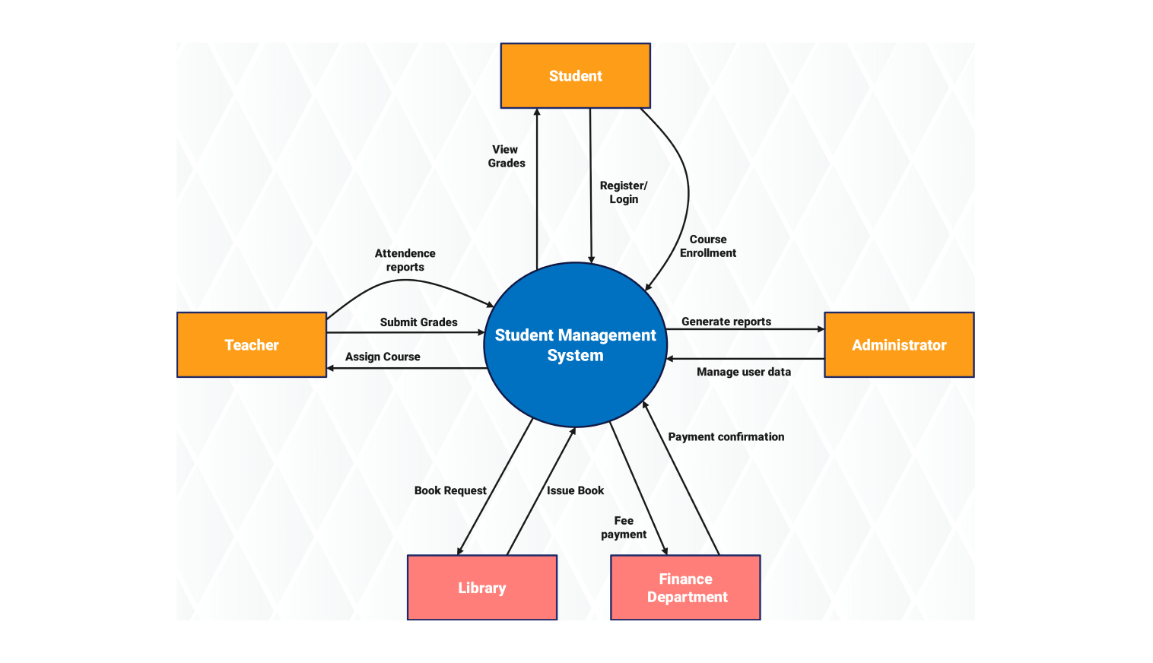

7. Implementation / Source Code and Environment / Tools Used

7.1 Environment and Tools
- Language: Python 3.12
- Database: SQLite 3 (via the built-in sqlite3 module — no external DB server required)
- Visualisation: Matplotlib 3.x for chart generation
- Version control: Git / GitHub (folder: Assignment_Problem)
- Editor / Runtime: any standard Python 3 environment (tested in a Linux container)

7.2 File Structure
- skms.py — Database class + SSDMS domain-logic class (core implementation)
- cli.py — interactive menu-driven front end
- demo.py — reproducible seed data + automated run of every feature (used for testing & evidence capture)
- make_charts.py — generates the result/validation charts from the seeded data
The full annotated source code is provided as a separate deliverable (Program – Code) and is also included as Appendix A of this report.

8. Test Cases and Expected / Actual Results
# | Test Case | Input | Expected Result | Actual Result
TC1 | Add student | name, roll, dept, year | New row in students table, no error | Pass — row inserted, id returned
TC2 | Duplicate roll number | roll_no already exists | UNIQUE constraint violation raised | Pass — sqlite3.IntegrityError raised as expected
TC3 | Record assessment, unknown student | student name not in DB | ValueError('Unknown student...') | Pass — exception raised, no row inserted
TC4 | Proficiency banding | score = 78 | Level = 'Advanced' | Pass — Rahul Verma, Python Programming -> 78 -> Advanced
TC5 | Skill gap analysis | Rahul Verma vs Data Analyst role | Readiness % computed, per-skill gap listed | Pass — readiness = 25.0%, SQL gap = 21 pts (see Sec. 9)
TC6 | Progress trend | Sneha Iyer, Python Programming, 3 rounds | 3 dated scores returned in chronological order | Pass — 56, 54, 58 across Jan/Feb/Mar 2026
TC7 | Leaderboard (overall) | top_n = 5 | 5 students ranked by average score, descending | Pass — Sneha Iyer ranked 1st at 59.0
TC8 | Leaderboard (per skill) | 'SQL & Databases', top_n = 3 | 3 students ranked by best SQL score | Pass — Sneha Iyer, Karan Mehta, Priya Nair

9. Execution Screenshots / Outputs
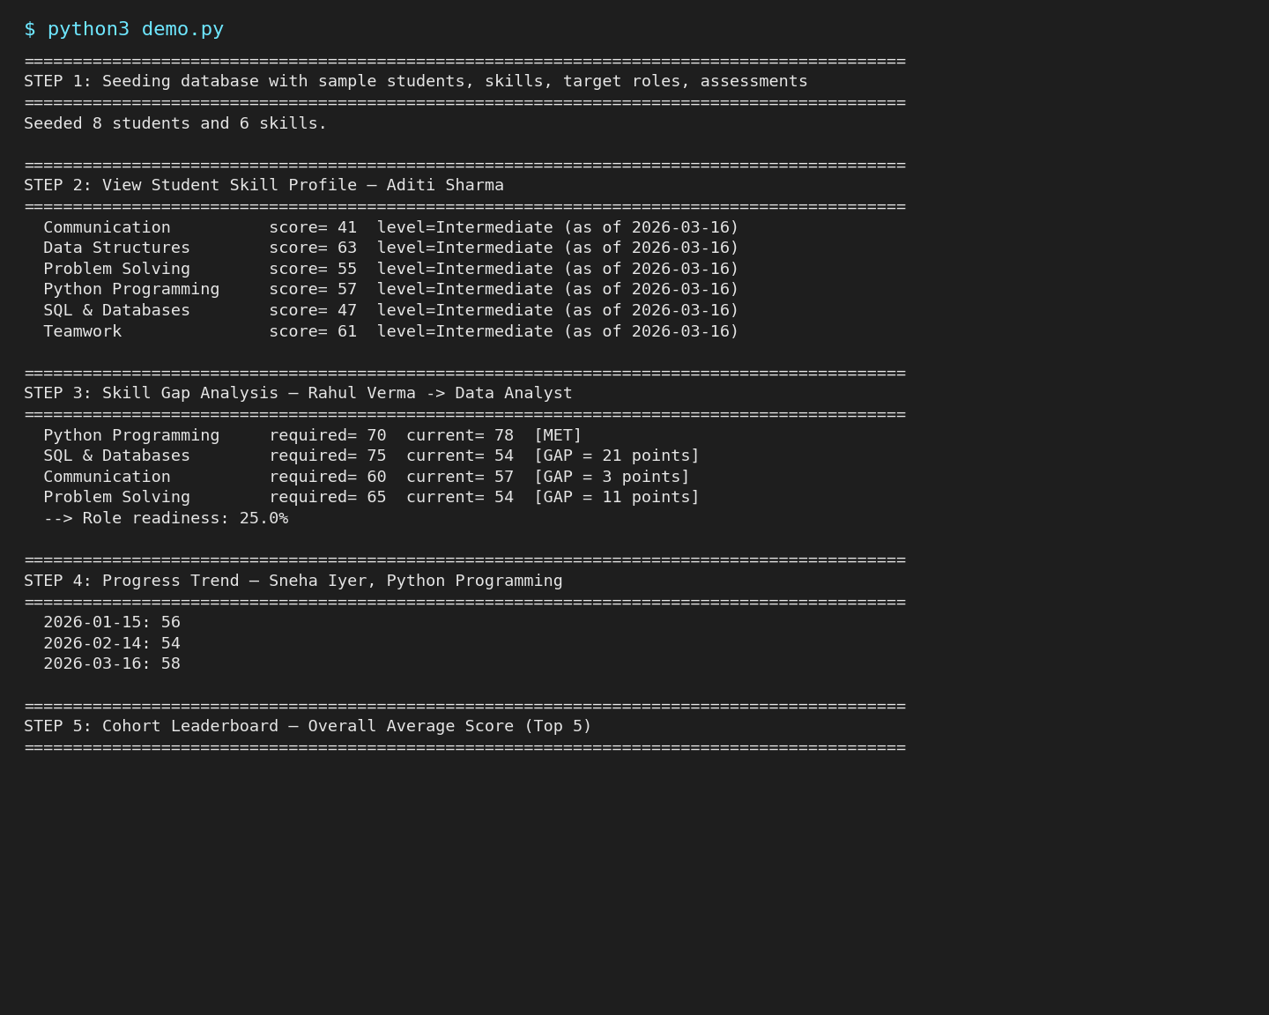
The complete, unabridged console transcript is provided in the separate 'Program – Output' document.

10. Results and Validation
Sample data for 8 students across 6 skills, assessed over 3 rounds (Jan–Mar 2026), was used to validate the reporting features.

10.1 Cohort Skill Strength / Weakness
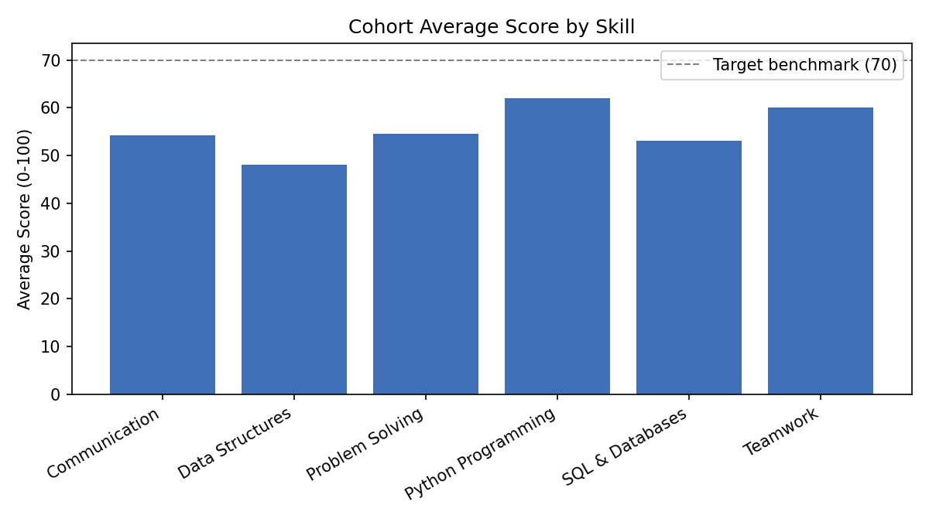

10.2 Individual Progress Over Time
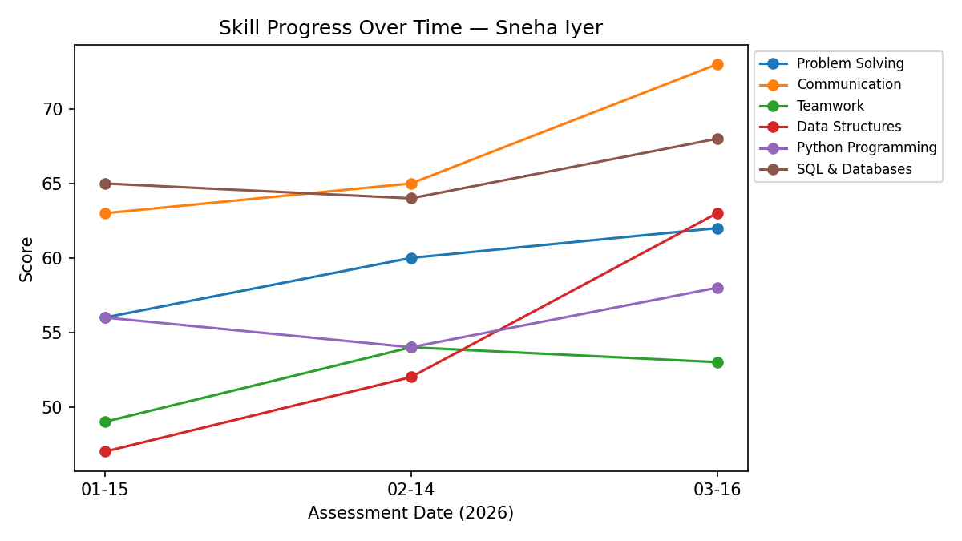

10.3 Role-Readiness Across the Cohort
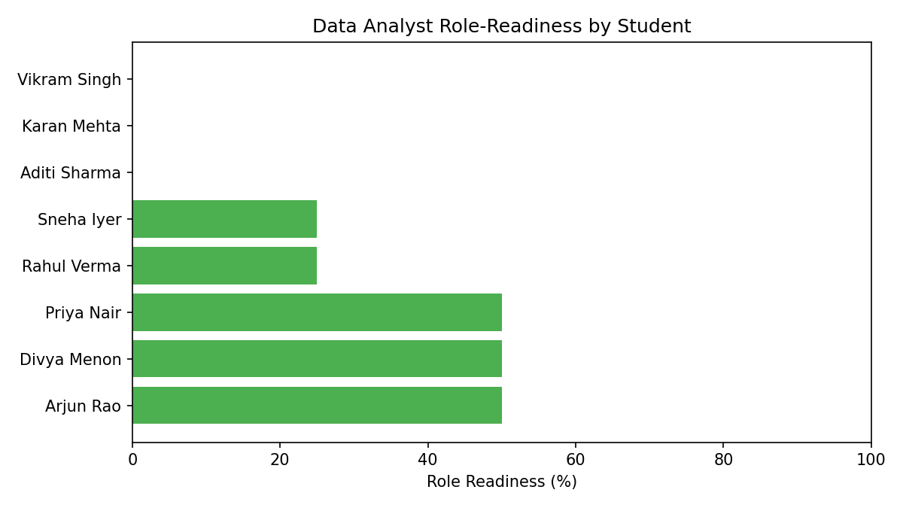

10.4 Performance Metrics
Metric | Value
Students seeded | 8
Skills tracked | 6
Assessment records generated | 144 (8 students × 6 skills × 3 rounds)
Average query time (profile/gap/trend) on this dataset | < 5 ms (in-process SQLite, indexed by primary key)
Target roles configured | 2 (Data Analyst, Software Engineer)

11. Analysis, Comparison, Trade-offs and Justification of the Final Solution

11.1 Design Alternatives Considered
Alternative | Pros | Cons | Verdict
Flat file / CSV storage | Very simple, no dependencies | No relational integrity, slow ad-hoc queries, hard to join students/skills/assessments | Rejected
Full web application (Flask + DB) | Richer UI, multi-user | Higher setup complexity, out of scope for a console capstone deliverable, harder to demonstrate reproducibly | Deferred to future work
SQLite + console CLI (chosen) | Zero external server, real SQL/relational modelling, fast to demo and grade, easy to reproduce output | Single-user, no authentication | Selected

11.2 Justification
SQLite was chosen over a flat-file approach because the domain has genuine relational structure (many-to-many relationships between students, skills, and roles) that benefits from SQL joins and constraints rather than manual file parsing. A console interface was chosen over a full web front-end because it keeps the deliverable self-contained, fast to run and grade, and lets the report focus on correctness of the underlying algorithms (banding, gap analysis, trend, ranking) rather than UI plumbing — while the layered design (Database / SSDMS / CLI) keeps a future web migration straightforward, since only the presentation layer would need to change.

12. Broader Considerations / SDG Relevance
This project directly supports UN Sustainable Development Goal 4 (Quality Education), specifically Target 4.4, which calls for substantially increasing the number of youth and adults who have relevant skills for employment. By making skill gaps and progress visible and measurable, the system helps mentors intervene earlier and helps students target the specific skills required for the careers they want, supporting more equitable and effective skill development.
It also has a secondary link to SDG 8 (Decent Work and Economic Growth) by helping better align graduating students' skill profiles with real labour-market role requirements, improving employability outcomes.

13. Conclusion, Limitations and Possible Improvements

13.1 Conclusion
The Student Skill Development Management System successfully demonstrates a relational, rule-based approach to tracking student skill development: it records dated assessments, classifies proficiency, quantifies gaps against target job roles, visualises progress, and ranks students — all validated against a reproducible sample dataset with automated test cases.

13.2 Limitations
- No authentication or role-based access control (any operator has full access).
- Single-user console interface; no concurrent multi-mentor usage.
- Proficiency bands and gap thresholds are static and not yet configurable per department.

13.3 Possible Improvements
- Migrate the presentation layer to a Flask/React web UI while reusing the existing SSDMS domain layer unchanged.
- Add authentication (mentor/admin roles) and audit logging of who recorded each assessment.
- Add configurable proficiency bands and role templates per department.
- Add CSV/Excel bulk-import of assessment data from existing spreadsheets.

14. Individual Contribution of Group Members
Member Name | Roll No. | Contribution
[Member 1 — Your Name] | [Roll No.] | Database & domain logic (skms.py), CLI (cli.py), report writing
[Member 2] | [Roll No.] | Test case design & execution, chart generation, One-page write-up
[Member 3] | [Roll No.] | GitHub setup, documentation, presentation of results

15. References
- Python Software Foundation. Python 3 documentation — sqlite3 module. https://docs.python.org/3/library/sqlite3.html
- SQLite Consortium. SQLite documentation. https://www.sqlite.org/docs.html
- Hunter, J. D. (2007). Matplotlib: A 2D graphics environment. Computing in Science & Engineering.
- United Nations. Sustainable Development Goal 4 — Quality Education. https://sdgs.un.org/goals/goal4
- Sample/synthetic dataset: generated by demo.py using a fixed random seed (42) for reproducibility — no external or personal data was used.
Appendix A: Source Code Listing
See the accompanying 'Program – Code' document / GitHub repository (Assignment_Problem/) for the complete, syntax-formatted source of skms.py, cli.py, demo.py and make_charts.py.

